**CIS 4930 Mobile Networks – Experiment 1**

**Leeson Chen, Andy Liu, Ricky Clarke**

**Part I: Bluetooth Encounter Trace Collection**

*This part is to introduce you to the encounter collection for both classic Bluetooth and BLE. Your goal is to compare and contrast the scanning result for both of them.*

1. Spend some time (around 10 days) running scanners around the campus.
2. Answer the following questions:
   1. How many encounters have been recorded in each scanner (plot over time, days, hrs)
   2. How many unique encounters (plot over time)
   3. What is the average number of scanned records? How many records have been scanned per minutes in each scanner?
   4. What is the max, min, mean of RSSI collected by scanners? (plot the distribution)

**Part II: Scanning Scenarios for Two specific devices**

*This part needs two devices and two users to perform the operation. (Several groups can team together if there is need for that). Also, the layout of the place needs to be known. We recommend the computer science hallway. The scenarios is described below:*

1. Classic Bluetooth Experiment
   1. 1st Scenario: Walking

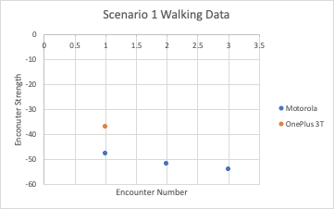

* 1. 2nd Scenario: Encounter

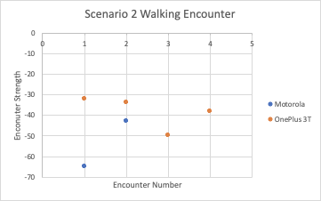

*Compare the data from each user for each scenario and plot them.*

1. BLE Experiment
   1. 1st Scenario: Walking
      1. High Energy
      2. Medium Energy
      3. Low Energy
      4. Ultra Low Energy

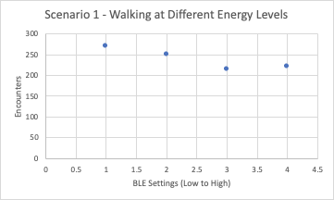

* 1. 2nd Scenario: Encounter
     1. High Energy
     2. Medium Energy
     3. Low Energy
     4. Ultra Low Energy

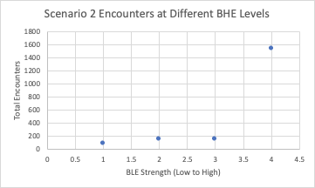

*Compare the collected data, and plot the received RSSI in each experiment.*

***Questions:***

1. *Can you deduce the scenario from the collected data? For example, by looking at the encounter data only, can you tell if the users are moving next to each other, or if the users just encounter each other, and for how long?*

Yes, a higher Bluetooth signal strength (closer to 0 than to -70) indicates that the two devices are closer together for a longer period of uninterrupted time, or at a higher BLE energy level. Lower RSSI indicates a quicker encounter, whereas a higher RSSI indicates a longer encounter.

1. *How can you use the transmission power and RSSI sent in the BLE to estimate the encounters between two users?*

A higher RSSI means that the devices were either closer together, together for a longer time, or transmitting at a higher BLE. If the BLE is provided, then that means we can deduce the time duration that the users were together for.

**Part III: Distance Estimation from RSSI**

1. *There are several models that have been used to estimate the distance from the RSSI. In this experiment, place the devices within a specific distance from each other: 0.5m, 1m, ...[X]. Plot the RSSI against the distance.*

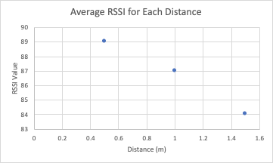

1. *Select a model [log shadowing model, Android beacon Library, or a regression model]. Compute the Mean Absolute Error of predicted distances.*

Log shadowing model:

d = 10(89 - 87)∕(-10 x 2)

d = 0.7943

Actual d = 0.5

Error = 0.294m

**Part IV: Constructing a Mobility Scenario from scanned RSSI and TX power**

1. Classic Bluetooth Experiment
2. BLE Experiment
   1. High Energy
   2. Medium Energy
   3. Low Energy
   4. Ultra Low Energy
3. *Run the above experiment several times using Classic Bluetooth. Then, run it using the BLE using a different TX_power setting.*
4. *Explain how you can infer the scenarios using the RSSI.*

If the device moving from point Z to Y does not stop at X, then the RSSI is very low (around -50 for the Motorola device we used). However, if the user stops at X for some number of minutes, then the data is similar to Part 2 of this scenario: relatively high RSSI, and potentially multiple “encounters” due to the signal faltering then checking in again.

1. *Is classic Bluetooth or BLE more accurate to construct the scenario? In case of BLE, which value of TX_power is more accurate for tracking purposes?*

BLE is more accurate, and medium power worked best for our experiment. This is because a higher-power BLE advertisement creates the “strongest” connection with least breaks, but this can be misleading because if the devices are just passing by each other, a high power advertisement will seem to show a longer encounter. Low and Ultra-Low power were too low to get consistent readings, at least under our experiment conditions.

**Part V: Make your extension to the experiment (extra points)**

1. *Come up with other scenarios, and estimate the encounters' duration between devices.*

We propose a scenario wherein three devices are used, two of them sending advertisements to a receiver but at different BLE energies (for example, one at high power and the other at ultra-low power). We assume that the high power BLE device would have a higher number of encounters, possibly even “blocking out” the lower energy BLE device.

1. *Can you come with an algorithm that deduces the scenarios of face-to-face encounters out of Bluetooth encounter data?*

An algorithm that can detect face-to-face encounters would likely scan the trove of data for longer durations of encounters, with possible breaks and re-connections of the two devices. This assumes that face-to-face includes both stopping next to each other, and also walking next to each other. If face-to-face only includes stopped motion, then the algorithm would also look for a lack of other new encounters during the time, indicating the devices are not being walked past other people’s devices.

1. *Some real encounters might not be recorded by Bluetooth scanning, can you come up with an algorithm that estimates the encounters that are not reported in the Bluetooth encounter data using the data that collected by the Bluetooth device.*

In order to extrapolate the number of false negatives from the data, one algorithm could look for “density” of encounters—i.e., the number of encounters averaged over any given minute. If there are any lapses below that average, one could assume devices were too far away or failed to be picked up by the Bluetooth signal. If access to other Bluetooth devices’ data is given, you could also look for nearby devices during the encounter with the original devices, to look for overlap that should exist but isn’t in the original data.

**Part VI: Make your extension to the experiment - Device – Dependent Model: (extra points)**

1. *Collect RSSI data from different advertisers with different brands, but use the same scanner for both advertisers*

We used two different brands: a phone by the company OnePlus, and a second (cheaper, lower-quality) phone by Motorola

1. *Compare the distribution of RSSI from a similar distances and similar TX power.*

Because the OnePlus was a higher-end phone than the Motorola, it was consistently better at both sending stronger advertisements, and for detecting other Bluetooth devices than the Motorola. In the BluetoothData.txt logs for example, the OnePlus phone had roughly 10x more Bluetooth encounters with nearby laptops and cell phones from the people around us, as well as detecting the Motorola with a strong RSSI. Conversely, the Motorola phone had relatively simple logs with few detections of nearby devices, and had a harder time detecting even the OnePlus phone when it was advertising.

1. *Develop and evaluate a distance estimation model for:*
   1. *All the collected data regardless of the advertiser*

Relative to the brand / device’s signal strength, RSSI decreases with distance. However, the lower-end brand’s strongest RSSI may still be equal to the higher-end brand’s middle or lowest RSSI.

* 1. *Model for data collected from device1*

The OnePlus phone we used consistently had an RSSI beginning at around -30, and then decreasing by about 5 points for consecutive checks during a walking encounter.

* 1. *Model for data collected from device2*

The Motorola phone we used consistently had an RSSI beginning at around -50, and then decreasing by 5 points for consecutive checks during a walking encounter.

1. *Based on your collected data and models evaluation, do you think there is a need for a device-dependent distance estimation model?*

Separating the devices by brand is a somewhat clumsy heuristic, because the strength of a device’s Bluetooth advertisement and reception can be limited or enhanced by many factors. In our case the newer, more expensive OnePlus device performed better under all scenarios than the cheaper Motorola phone—but this could easily be inversed. For example, if we had used the very first, older version of the OnePlus versus a brand-new 2020 model high end Motorola phone, the results might be the complete opposite. The Bluetooth chip is also independent of brand, and is decided also by price bracket and recency. Therefore you have to take into account the age of the device and its Bluetooth chip rather than purely the brand name.